**IMAGES OF CMATCHES APPLICATION**

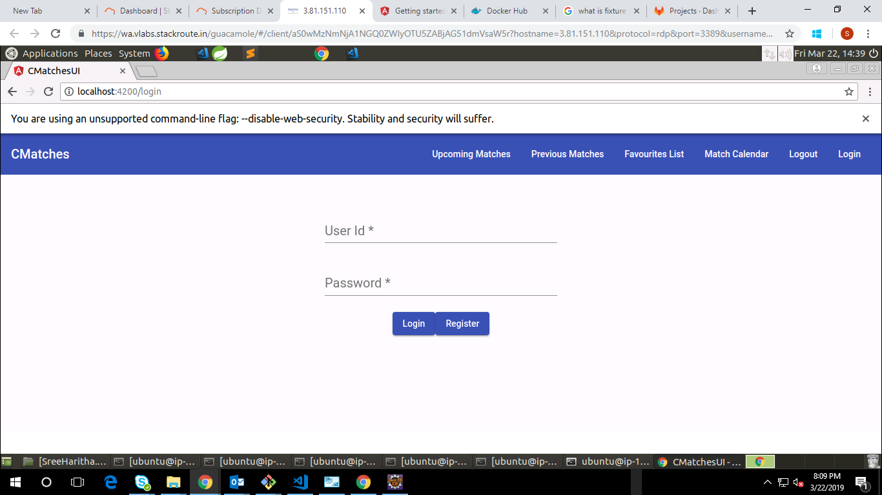

Fig :1 C-Matches Landing page

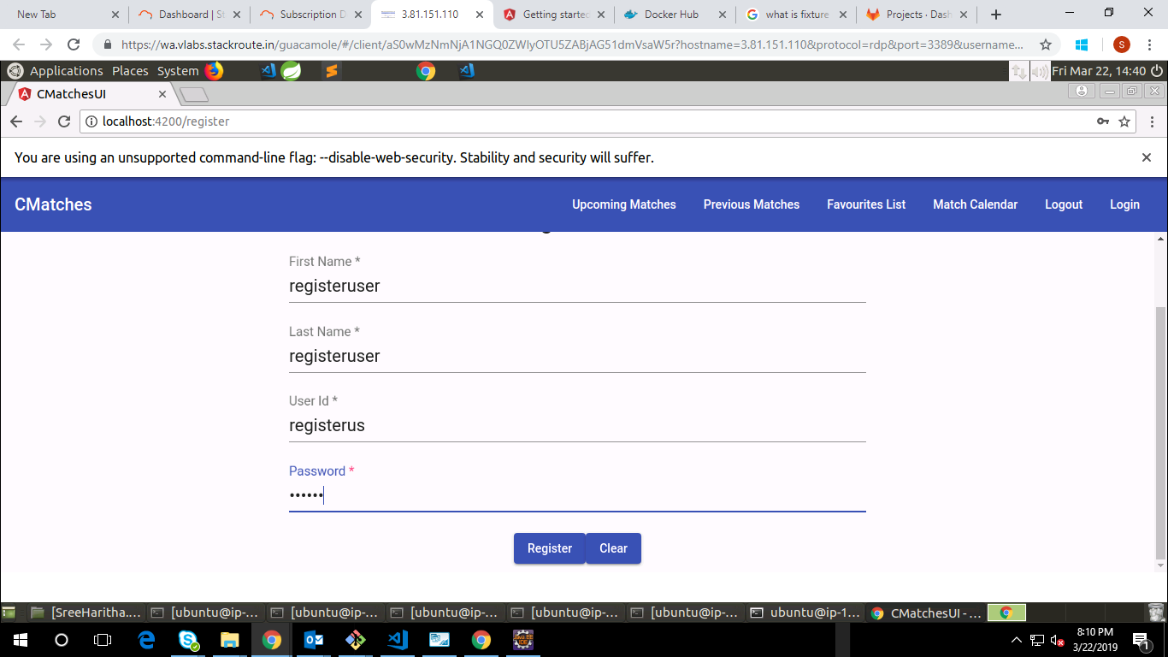

Fig :2 C-Matches Register page

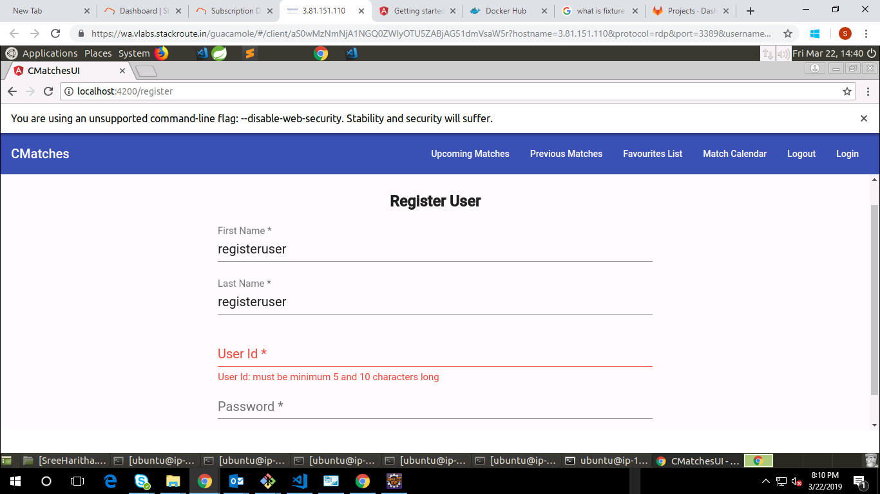

Fig :3 C-Matches Register page field validations

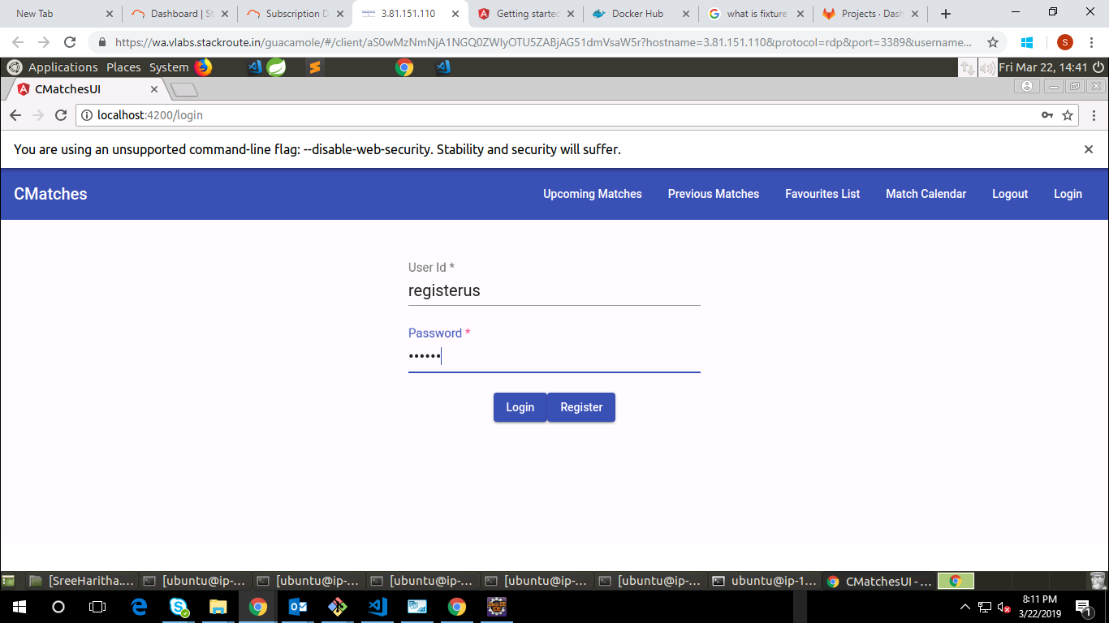

Fig :4 Navigation to login page after successful registration

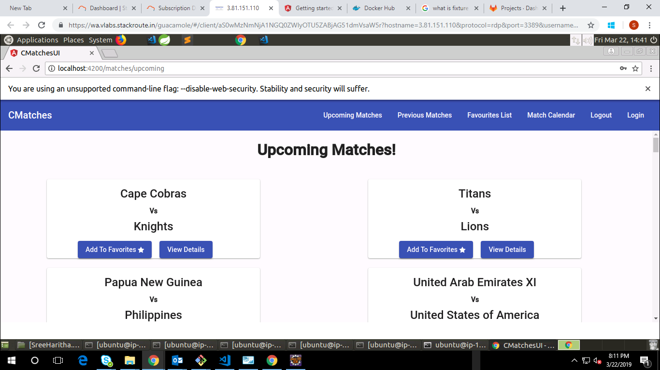

Fig :5 Navigation to upcoming matches page

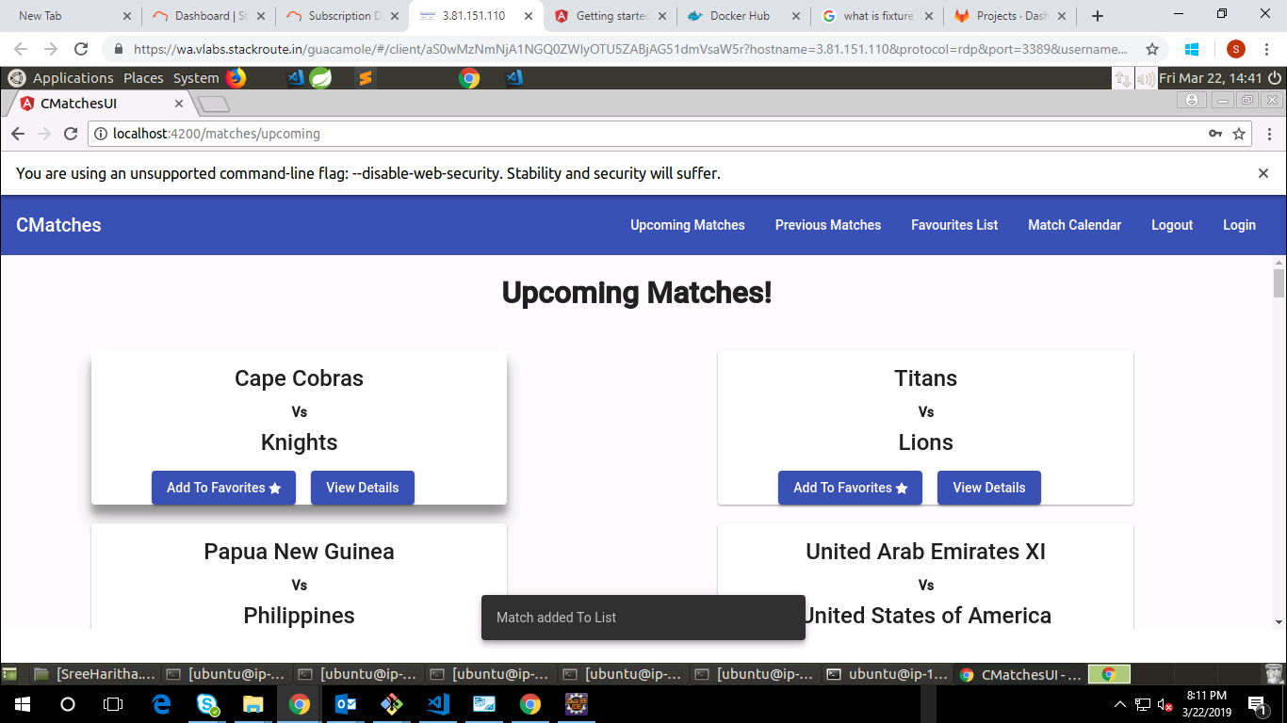

Fig :6 Snack bar message after adding to favourites

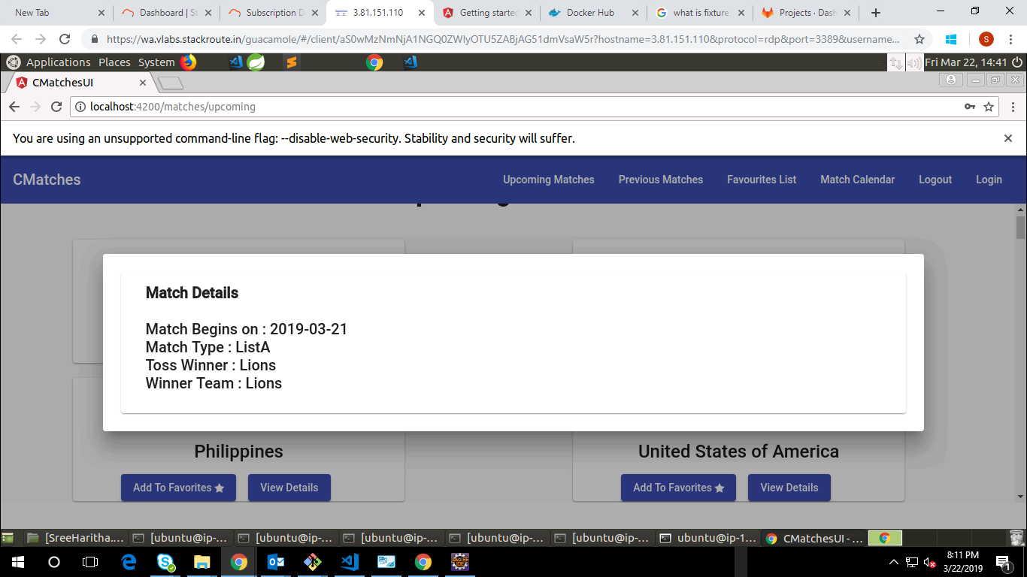

Fig :7 view details dialog box

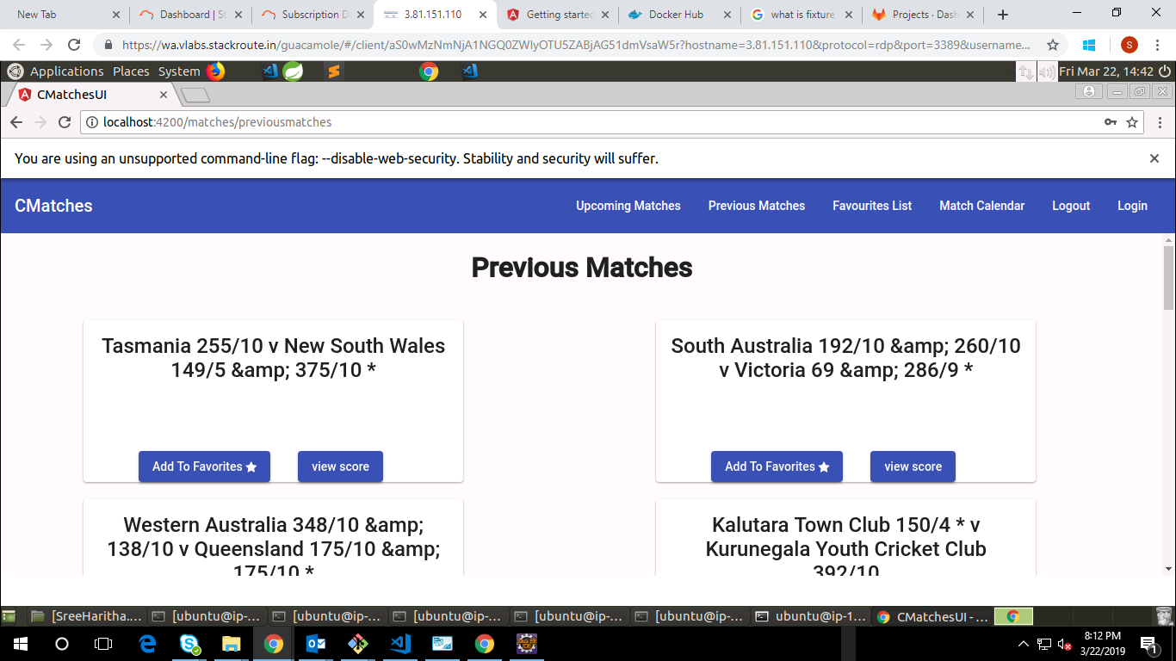

Fig :8 Navigation to previous matches page

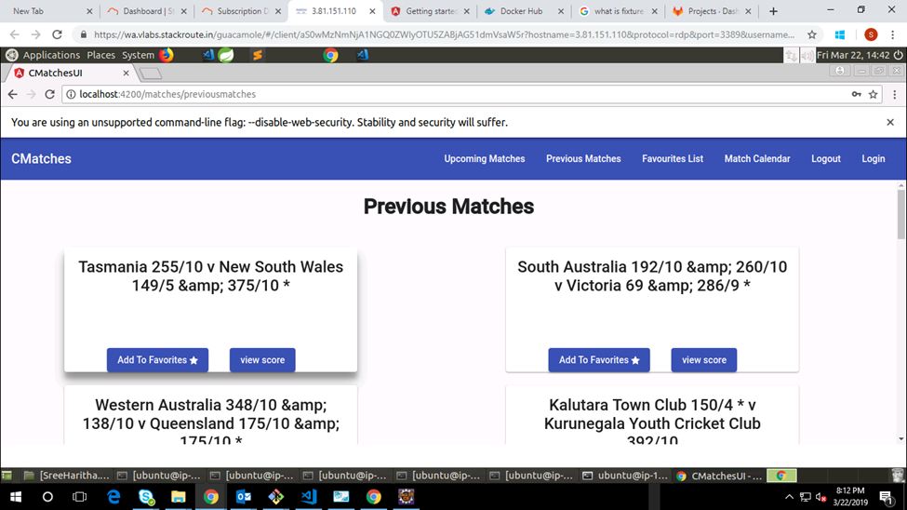

Fig :9 Cards hover effect

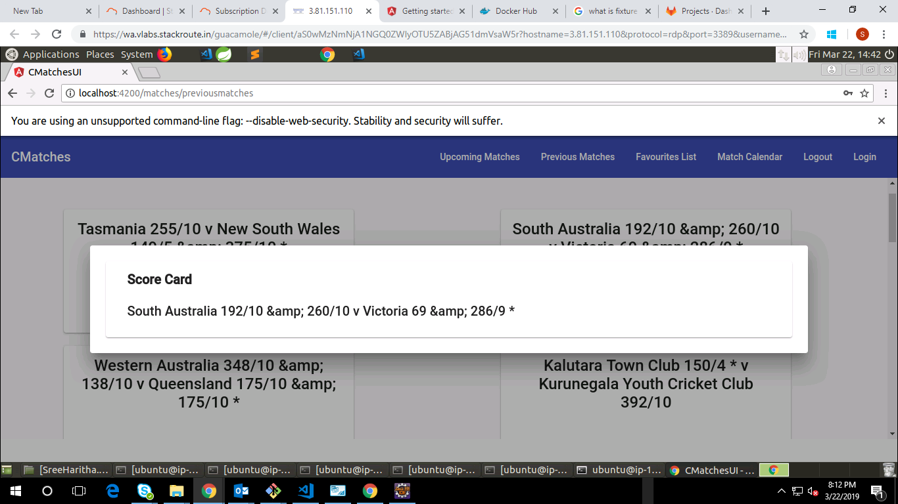

Fig :10 view score dialog box

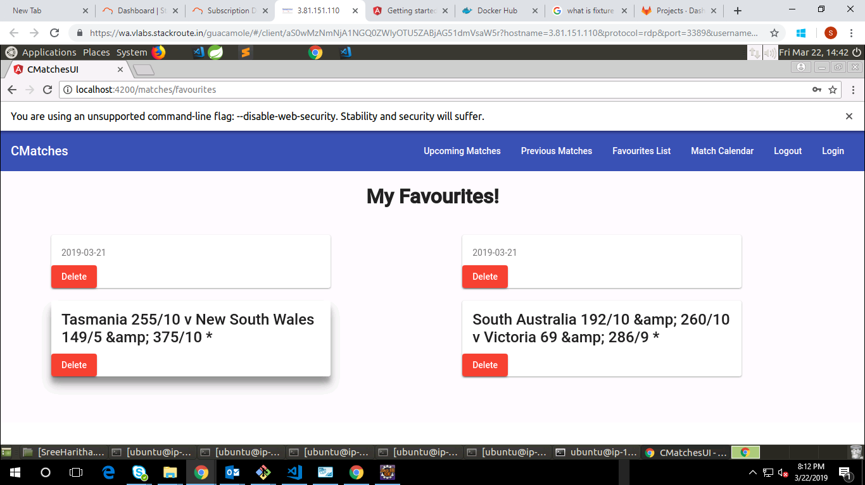

Fig :11 Favourites Page

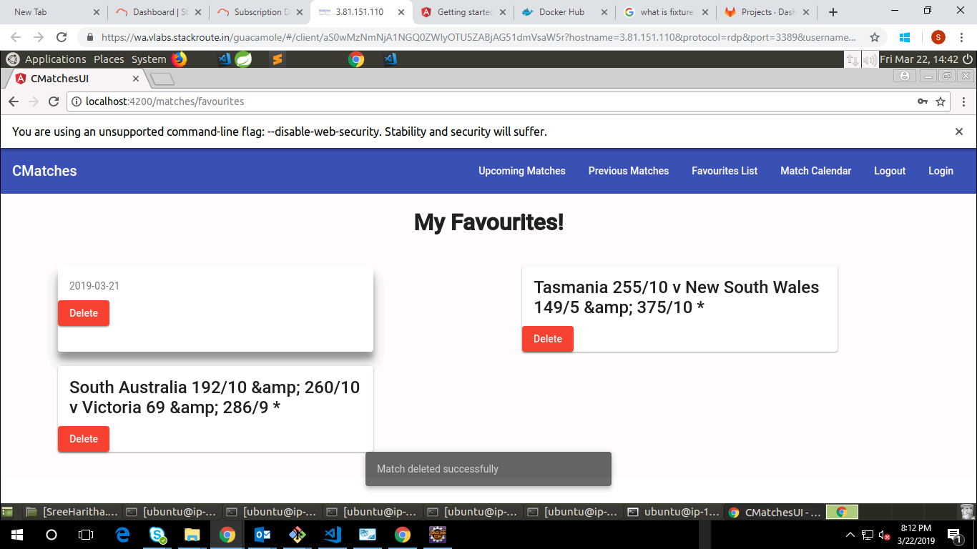

Fig :12 Snack bar message after deleting match from favourites

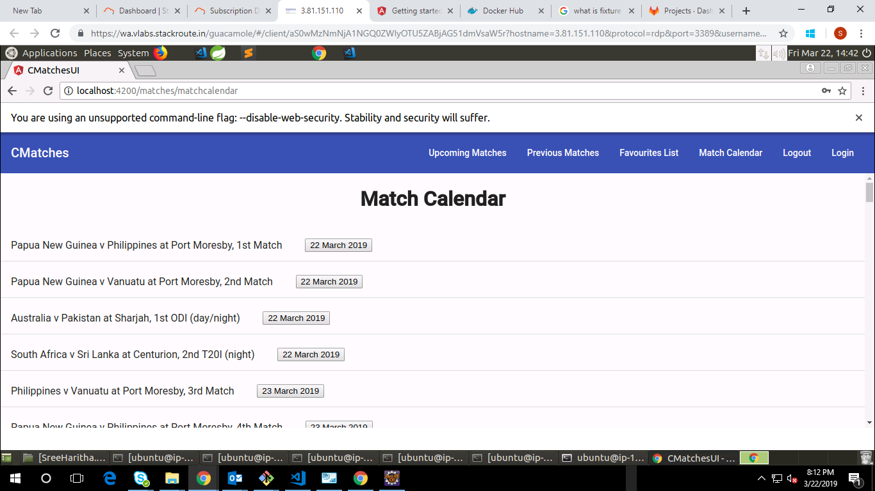

Fig :13 Navigation to match calendar page

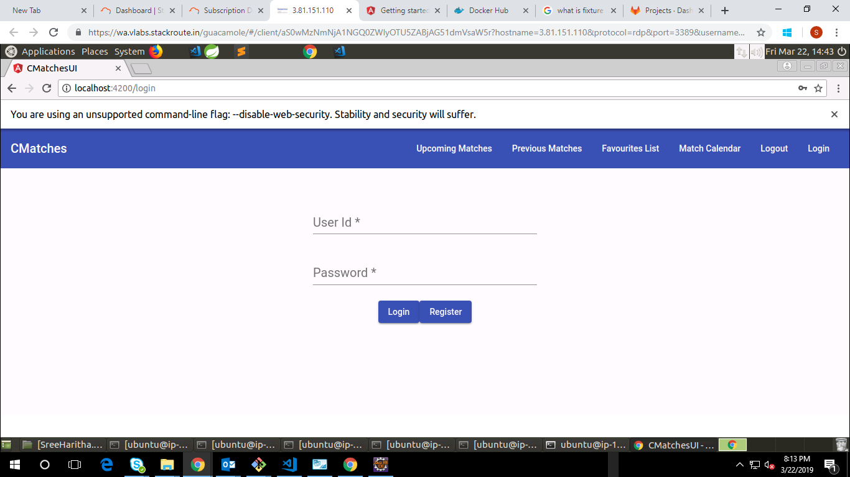

Fig :14 Navigation to login page after logging out